THE SEVEN JUMP MODEL FOR PBL

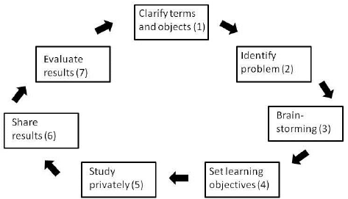

- TEACHER INPUT (LECTURES, WRITTEN RESOURCES, RUBRICS)
- CLEARLY STATE THE QUESTION OR PROBLEM
- TUTORIAL GROUPS MEET BRIEFLY TO DISCUSS THE PROBLEM
- TEACHER STATES THE OBJECTIVE (TO ANSWER A QUESTION, WRITE AN ESSAY, SOLVE AN EQUATION, ETC)
- STUDENTS RESEARCH INDEPENDENTLY *
- TUTORIAL GROUPS MEET AND SHARE RESEARCH
- TUTORIAL GROUPS MEET AND FORMULATE ONE PRODUCT* **
*GRADED WORK.
** TIMED WORK.
WHY IT WORKS:
STUDENTS ARE RELYING ON ONE ANOTHER TO DO THE HOMEWORK.
STUDENTS MUST JUDGE THEIR OWN RESEARCH, AS WELL AS OTHER STUDENTS RESEARCH.
STUDENTS ARE ENPOWERED TO DRIVE THE PROCESS. TEACHERS ARE THERE TO GUIDE, BUT ALLOW STUDENTS TO DO THE TALKING. LET THEM HAVE OWNERSHIP.
EACH GROUP MEMBER: IS PREPARED AND PARTICIPATES.
FACILITATOR: SETS THE AGENDA, GUIDES THE DISCUSSION, ENCOURAGES PARTICIPATION AND SUMMARIZES THE DISCUSSION.
SCRIBE: TAKES NOTES AND WRITES FINAL PRODUCT.

STUDENTS CAN USE GOOGLE DOCS AND SHARE WITH MEMBERS TO EDIT. HELPFUL IF A STUDENT IS ABSENT.

TEACHER: ASSISTS DISCUSSION, CREATES WELCOME LEARNING ENVIRONMENT, CONTRIBUTES KNOWLEDGE AND EXPERIENCE, QUESTIONS EVERYTHING.

Intro to PBL

PBL at Maastricht University

Using PBL for AP classes
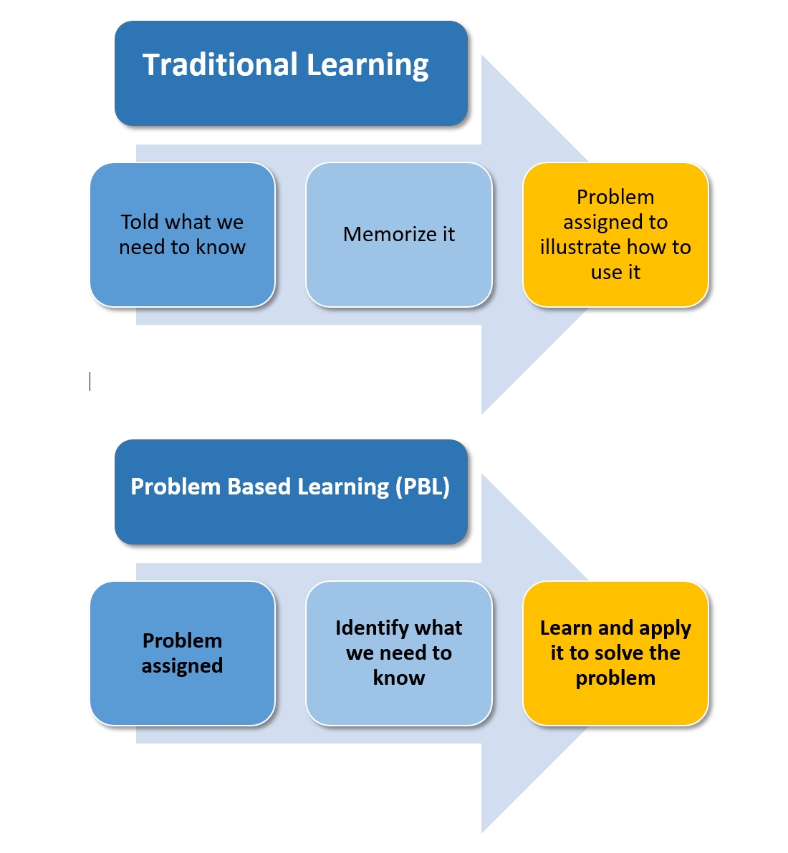

Sammamish High School, Bellevue, Washington started using PBL across the AP curriculum in 2010.

TaBle 2.
Statistically significant gains in mean ap scores by course
Course | Comparison group (no pBl exposure) mean ap score | Treatment group (pBl exposure) mean ap score
ap Biology | 1.67 | 1.97
ap Chemistry | 1.77 | 2.13
ap physics (combined) | 2.78 | 3.61
ap Calculus (combined) | 2.53 | 3.01
ap Statistics | 1.91 | 2.36
ap u.S. government | 2.27 | 2.74
ap psychology | 2.28 | 3.06
ap u.S. history | 1.85 | 2.69

TaBle 3.
Statistically significant gains by students who speak a first language other than english at home in mean ap scores by course
Course | Comparison group (no pBl exposure) mean ap score | Treatment group (pBl exposure) mean ap score
ap Calculus (combined) | 2.08 | 2.77
ap Statistics | 1.43 | 2.10
ap Chemistry | 1.41 | 1.93
ap physics (combined) | 2.53 | 3.53
ap u.S. government | 1.66 | 2.40
ap psychology | 1.64 | 2.97
ap u.S. history | 1.58 | 2.26
ap World history | 1.95 | 2.28

Enrollment: about 1000 students.
- 47% White, 5% Black, 18% Hispanic, 21% Asian, 8% Multiethnic
- 38% Free/Reduced Lunch Price
- 12% Enrolled in Special Education Programs
- 32% English as Second Language
- 47% Children of Parents with Only High School Education

TaBle 4.
Statistically significant gains by students who receive free and reduced-price lunch in mean ap scores by course
Course | Comparison group (no pBl exposure) mean ap score | Treatment group (pBl exposure) mean ap score
ap Biology | 1.18 | 1.57
ap Chemistry | 1.13 | 1.90
ap environmental Science | 1.36 | 1.76
ap Statistics | 1.31 | 2.03
ap psychology | 1.76 | 2.48
ap u.S. history | 1.56 | 2.13
ap World history | 1.91 | 2.32

TaBle 5.
Statistically significant gains by students with disabilities in mean ap scores by course
Course | Comparison group (no pBl exposure) mean ap score | Treatment group (pBl ex- posure) mean ap score
ap Calculus (Combined) | 1.89 | 2.93
ap Statistics | 1.32 | 2.20
ap physics (Combined) | 2.33 | 3.00
ap u.S. government | 1.36 | 2.07

Source: Sutton and Knuth, A Schoolwide Investment in Problem-Based Learning. Kappan, October 2017.

Some universities that use PBL:
Stanford University
University of Alberta
Maastricht University
Aalborg University
McMaster University
Spaulding University
University of Delaware
University of Leicester
Western University of Health Sciences
University of Limerick
University of Exeter
Middle Tennessee State University
West Point
University of York Law School
Manchester Metropolitan University
University of Georgia USA
University of Colorado Denver
Howard University
University of Florida
The Open University UK
University of Firenze
Northern Illinois University
Penn State
University of Sydney

