RENAISSANCE LEQ
Compare the visual and document below, and summarize in writing the ways in which they reflect the values of the Renaissance.
From: Oration on the Dignity of Man
written by Pico Della Mirandola
"I have set thee," say the Creator to Adam, "in the midst of the world, that thou mayst the more easily behold and see all that is therein. I created thee a being neither heavenly nor earthly, neither mortal nor immortal only, that thou mightest be free to shape and to overcome thyself. Thou mayst sink into a beast, and be born anew to divine likeness....To thee alone is given a growth and a development depending on thine own free will."
From Michelangelo's scene on the Moment of Man's Creation,
Sistine Chapel
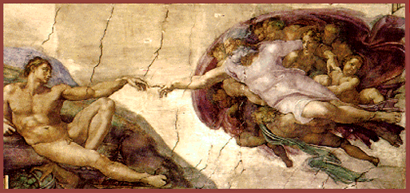

Research first, bring your findings to PBL tutorial group.
What are the values of the Renaissance?
4 paragraphs:
- Introduction with thesis
- Body paragraph 3. Body paragraph 4. Short conclusion

